Student Name: Yuyang Gong Student Number: 49079984 Team Name: FriendZone
Week: 6
Title: Building and Refining the FriendZone Prototype

Description:
The first interactive prototype introduced onboarding, interest selection, recommended circles, group chat, prompts and participation rewards. Subsequent iterations improved matching by recommending relevant circles, added optional profile details, expanded interest selection and introduced search, circle creation and an in-person mode.
These iterations made the concept more complete, but they also exposed a risk: the application could become another broad social platform. We therefore reviewed which features directly supported the core transition from uncertainty to real-world participation and which features were only adding complexity.
Visual Evidence:
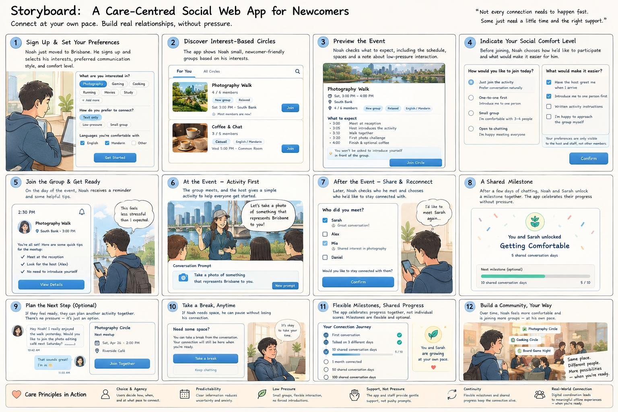
Refined storyboard for the care-centred FriendZone web application.
Statement on Learning:
I learned that adding functionality is not the same as strengthening a concept. Iteration should make the central interaction clearer, not simply make the prototype larger. The prototype became most useful when it allowed us to question our assumptions and identify which parts needed evidence or simplification.

